**Create IBM Watson IOT Platform And Device**

|  |  |
| --- | --- |
| Date | 19 November 2022 |
| Team ID | PNT2022TMID47580 |
| Project Name | Smart Solutions for Railways |

**IBM Watson IOT Platform:**

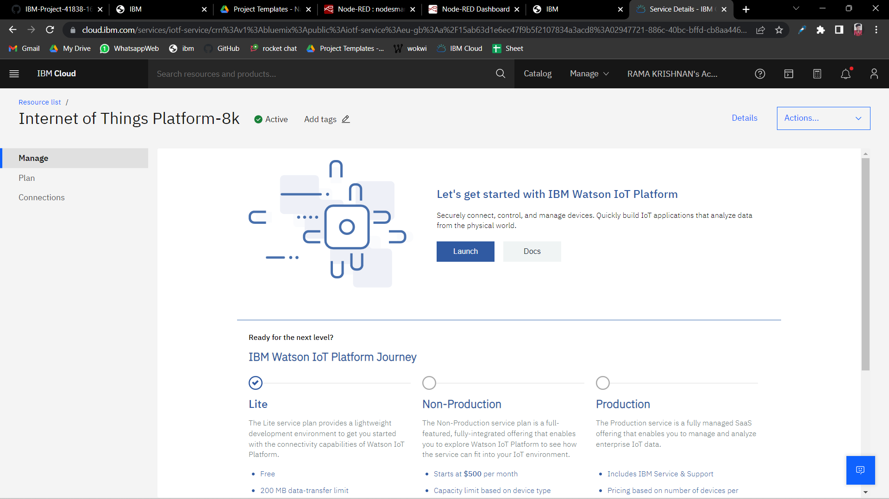

**Device in IBM Watson:**

